ZORG HEREDITY
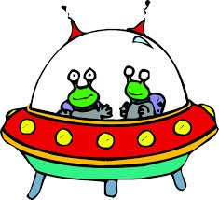

You are an astronaut traveling the universe when suddenly your spaceship breaks down. Thankfully, you are able to make an emergency landing on a mysterious planet. You shockingly discover that this planet is inhabited by strange alien creatures called ZORGS. Luckily for you, the ZORGS agree not to eat you and help you fix your ship.
While on the planet, you notice that the ZORGS have many different traits. You want to record the different ZORG traits to tell everyone when you get back to earth:
- Most have red eyes while others have purple eyes
- Most have tails while others have no tails
- Most have long legs while others have stubby, short legs
- Most have a horn, while others have no horn

DIRECTIONS – In your journal, title the next right page “ZORG heredity”. This will most likely take two journal pages. When you are finished, answer the 3 journal questions in complete sentences (you do not have to write questions)
- Make a chart listing the traits and characteristics found among ZORGS (see example on board)
- Draw 8 different examples of ZORGS using the combination of traits above
- Label your ZORGS as 4 females and 4 males

REFLECTION QUESTIONS- (do not write, answer in complete sentences)
- Which ZORG traits are DOMINANT?
- Which ZORG traits are RECESSIVE?
- Describe the difference between a ZORG’s genotype and phenotype.

